2019 TRAINERS’ HANDBOOK
This handbook should be read in conjunction with the SMJFL By-Laws which are available on the league website

INSERT CLUB LOGO HERE

Trainers Role and Responsibilities

Availability
Present for all team matches (home and away).

First Aid Training

Essential Duties

Pre-Game
- Make yourself known to the opposition team’s Trainer, ground trainer and/or ground manager (if applicable).
- Ensure you are familiar with location of essential emergency equipment
- Ensure first aid kit is present, and appropriately stocked (strapping tape, bandages, gauze, etc.) (Refer Checklist - Appendix 1)
- Ensure you have access to ice
- Conduct pre-game check with players re: injury concerns, any strapping required, etc.
- Provide any feedback to coach on any individual player concerns

During Game
- Assess injuries and, if required, liaise with home ground Trainer and/or appropriate club personnel
- Complete an Injury Report for such incidents (Refer Appendix 2)
- Provide feedback to coach on any individual player concerns

Post-Game
- Diagnosis, management, rehabilitation (in conjunction with Head Trainer as necessary, and feedback to coach)
- Keep records as per club requirements

Player/Personal Protection and Medical Information

Club Committee & Key Contacts

Name (Position) | Contact Details

Relevant Policies

Trainers Role - Statement from the AFL
The AFL expects that football matches at all levels will be played in good quality environments and the safety of participants is central to that environment.
Sports trainers and first aiders have been part of Australian Football since the origins of the game. They are part of the fabric of every club and play a key role in player preparation and safety at all levels.

In community Australian Football clubs, first aid is usually provided by sports trainers or by other volunteers with medical or higher level allied health (e.g. nursing, physiotherapy, occupational health & safety) qualifications and experience. Sports trainers are likely to play a more major role when there is no-one else with medical or allied health qualifications at a game or training. It is important that sports trainers, and others, are well trained in the first aid needs specifically relevant to Australian Football at the level at which they are involved (e.g. Auskick, juniors, youth, seniors, females, talent pathway, AFL clubs, veterans etc).

The Australian Football League (AFL) believes that planning and practicing what to do when an emergency occurs is an essential part of risk management. All football leagues and clubs must be conversant with first aid procedures and able to deal with emergencies so participants are well cared for. All leagues and clubs should ensure that:
- A person with current first aid qualifications is available at all football games and training sessions.

- An appropriately and adequately stocked first aid kit and well maintained sport-specific rescue/transport equipment are accessible at all training and competition venues.

South Metro Junior Football League (SMJFL) – Policy & By-Laws
The SMJFL supports the Sports Trainers in Community Australian Football Policy which is available on the AFL Victoria website.

Relevant SMJFL By-Laws
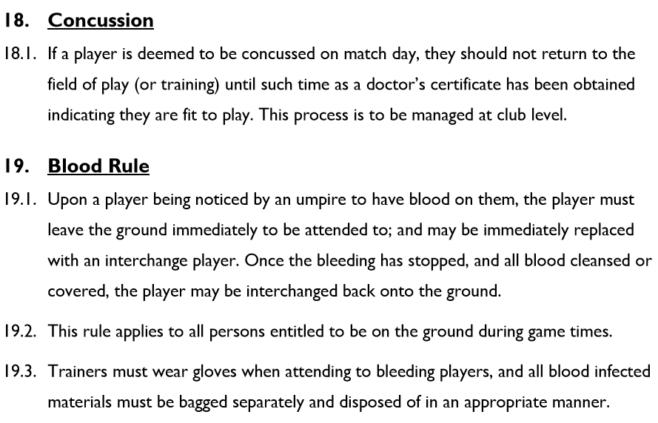

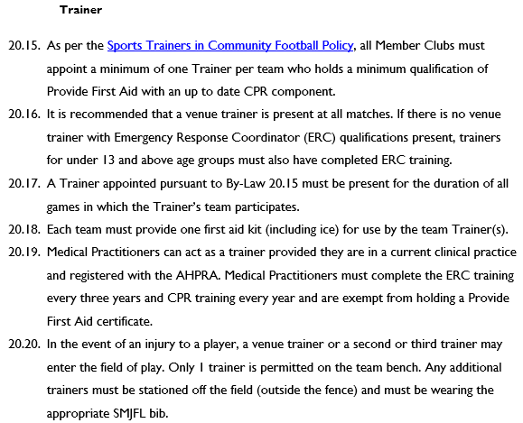

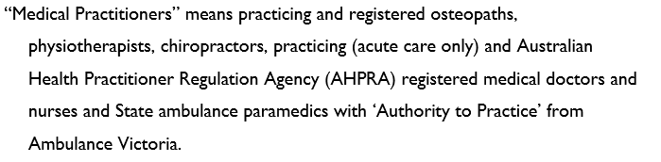

Location of Key Equipment

Item | Location
Defibrillator
Stretcher
Ice
Medical Supplies/ Tape

Emergency Information

Nearest Hospitals

Emergency Access to Grounds

Follow Up Procedures

Club Insurance

HANDY RESOURCES

SMJFL By-Laws
SMJFL By-Laws can be found under Rules, By-Laws and Policies on the SMJFL website: www.smjfl.com.au.

AFL Policy
The Sports Trainers in Community Australian Football Policy can be found on the AFL Victoria website: www.aflvic.com.au.

AFL Community Club
The following resources can be found on the AFL Community Club website: www.aflcommunityclub.com.au:
- Management of Concussion
- Helmets & Mouthguards
- The Management of Injuries and Medical Emergencies in Community Australian Football
- Stretchers and Cervical Collars
- Musculoskeletal Screening for Australian Football
- Growth Related Injuries in Junior Footballers
- Soft Tissue Injuries
- Hamstring Strains

Appendix 1 – First Aid Kit
The following checklist is provided as a guide of what the first aid kit should include but is by no means exhaustive, for example players with asthma may require a Ventolin inhaler.

Item | QTY | Item | QTY
Hygiene & PPE |  | Dressings
CPR Face Shield | 1 | Low/Non Adherent Large | 2
Tissues (pack) | 1 | Low/Non Adherent Small | 3
Nitrile Gloves (pair) | 5 | Island Dressing Large | 2
Antiseptic & Cleaning |  | Island Dressing Small | 3
Saline Ampule | 5 | Eye Pad (Sterile) | 2
Alcohol Swab | 4 | Gauze Swabs Sterile 7.5cm | 4
Iodine Swab | 4 | Flesh Colour Strips | 20
Hand sanitiser | 1 | Fabric Strips | 20
Safety pins (small bag) | 1 | Wound Closure Strips | 5
Freezer Bags (packet) | 1 | Misc. General
Adhesives |  | Rigid First Aid Box | 1
Micropore Tape 2.5cm | 1 | Thermal Blanket | 1
Rigid Sports Tape | 1 | Instant Ice Packs | 4
Bandages |  | Stainless Steel Scissors | 1
Cotton Crepe, 5cm | 2 | Note Pad & Pen | 1
Cotton Crepe, 7.5cm | 2 | Diabetic
Heavy Weight Bandage 7.5cm | 2 | Jelly Beans (small bag) | 1
Triangular 110cm | 2

Appendix 2 – Injury Reporting Form

